# Subsetting Columns - State and Family Members

This document includes the question, the solution, and a breakdown of the code provided in the screenshot.

## Uploaded Screenshot

Below is the screenshot of the task:

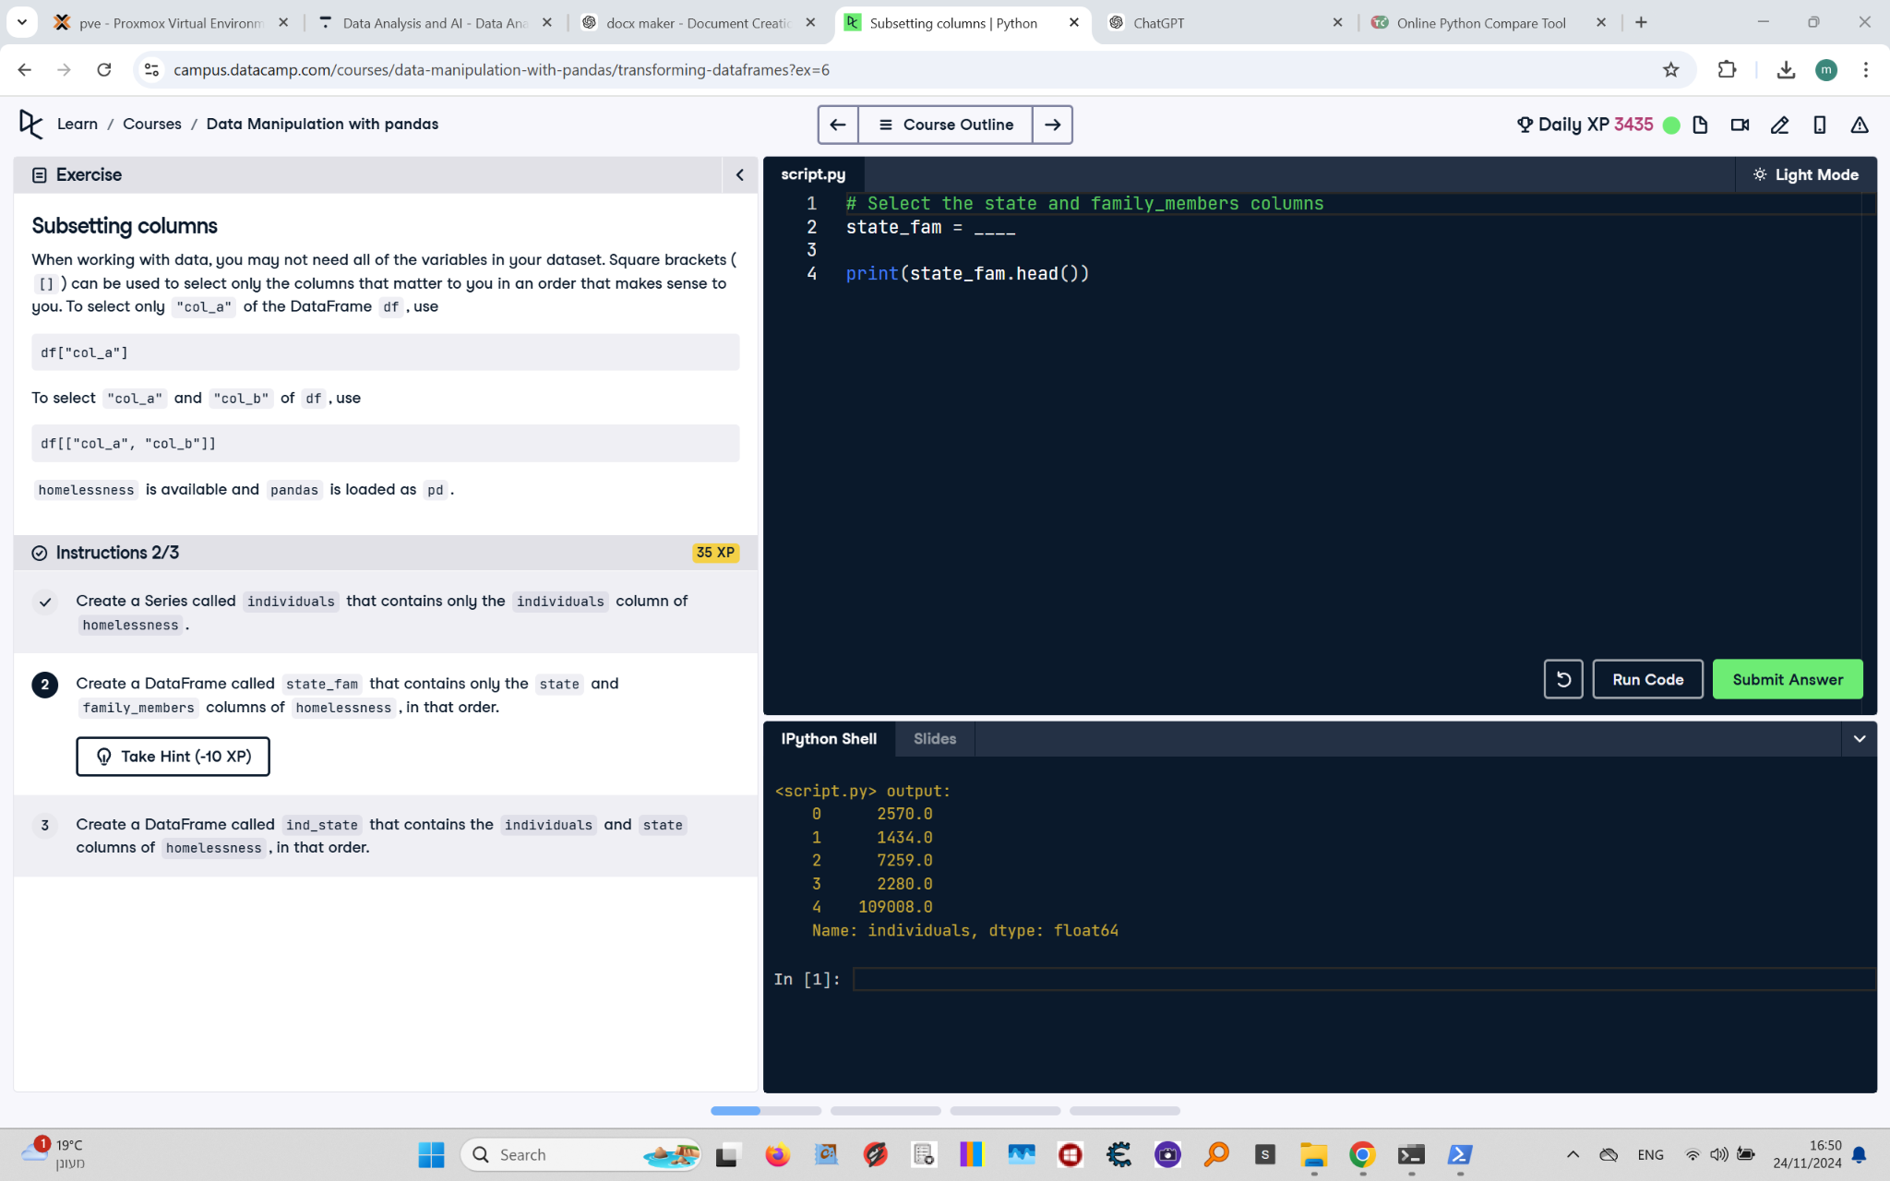

## Question

Create a DataFrame called `state_fam` that contains only the `state` and `family_members` columns of homelessness, in that order. Print the first few rows of the DataFrame.

## Answer

# Select the state and family_members columns  
state_fam = homelessness[["state", "family_members"]]  
  
# Print the first few rows  
print(state_fam.head())

## Code Explanation

# Explanation of the code:

1. `homelessness[["state", "family_members"]]`: Selects the `state` and `family_members` columns from the `homelessness` DataFrame.

- The double square brackets `[[ ]]` are used to select multiple columns.

2. `state_fam`: Stores the resulting DataFrame with the selected columns.

3. `print(state_fam.head())`: Displays the first five rows of the `state_fam` DataFrame to check its contents.